CS 340 Project Two
Leanna Walker
Grazioso Salvare Search and Rescue Dashboard
This project is a dashboard for the international rescue animal training company, Grazioso Salvare. The purpose is for users to search the animal shelter database for specific criteria and identify dogs that would be good to train as rescue dogs. Through the dashboard, users can filter by rescue types including Water, Mountain, and Disaster, view the results in a table, see a pie chart of breeds, and click on a map marker to see an animal’s location. The dashboard works by pulling data from a MongoDB Database using a custom CRUD Python module, then displays it in the table, chart, and map.

Motivation
The motivation behind the Grazioso Dashboard is to help the user search animal shelter databases more efficiently to find dogs that are good candidates for search-and-rescue training. Certain breeds and physical traits are better suited for specific types of rescues, such as water or mountainous conditions. This dashboard filters through large amounts of animal shelter data quickly based on the user’s specifications. Then it displays the filtered data visually with an interactive map showing the location of each dog, as well as a pie chart showing breed percentages. This helps the user instantly find the type of dog they are looking for.

Getting Started
Before you can use the dashboard, you need to set up the database and the CRUD module. Please refer to the detailed instructions in the CRUD Module for Austin Animal Center Database README or follow these summarized steps:
- Import the AAC dataset into MongoDB with an animals collection using the mongoimport command.
- Create a user named “aacuser” in the mongo shell that can read and write to the AAC database.
- Save the CRUD_Python_Module in a project folder.
Running the Dashboard
- Clone this repository or download and extract the zip file containing the project files.
- Open the ProjectTwoDashboard.ipynb file in Jupyter Notebook. You can also use VS Code or any other program that supports Jupyter notebooks.
- Run all of the cells in the notebook.
- Once the dashboard starts, it will give you a URL. Click that to open it in your browser.
Installation
To run this dashboard: MongoDB, pymongo, and Python, Dash, Plotly, and Dash Leaflet.
- MongoDB – This is the database that stores the AAC animal records. MongoDB is simple to install and works well with Python dictionaries and the pymongo library. Download it from the official MongoDB website and use the steps provided in the installation guide for your operating system. MongoDB stores animal records as documents that look like Python dictionaries, which makes it easy for Python to read and write the data using the pymongo library.
- pymongo – This is the Python library that connects my code to MongoDB. I chose pymongo because it is the official Python library for MongoDB and it is easy to use. Install it by running this in your command prompt if you use Windows or terminal for Linux or Mac:

pip install pymongo

- Python 3 – I wrote the program in Python, so you need Python installed on the computer in order for the .py files to run. Download Python 3 from the official website python.org and follow the install steps provided for your specific operating system.
- Dash – This is a Python library that is used to build the web dashboard layout. I chose Dash because it is the most widely used for Python dashboards ( https://dash.plotly.com ) and let me build the whole dashboard in one Python file. Dash builds the layout of the dashboard and also runs callbacks that respond when the user clicks radio buttons or select rows. Install it by running this in your command prompt if you use Windows or terminal for Linux or Mac:

pip install dash
- Plotly – This is a library that I used to create the pie chart, I chose it because it works well with Dash (https://plotly.com/python/) and the pie chart updates automatically when the table changes. Install it by running this in your command prompt if you use Windows or terminal for Linux or Mac:

pip install plotly

- Dash Leaflet – This is a Dash add on that adds interactive maps to the dashboard. Dash Leaflet is the official map tool for Dash (https://dash-leaflet.com/) and makes it very easy to show the animal locations on the map. Install it by running this in your command prompt if you use Windows or terminal for Linux or Mac:

pip install dash-leaflet

Usage

Code Example
This is a short example of the dashboard radio buttons:
dcc.RadioItems(
id=“rescue_filter”,
options=[
{‘label’: ‘Water Rescue’, ‘value’: ‘water’},
{‘label’: ‘Mountain Rescue’, ‘value’: ‘mountain’},
{‘label’: ‘Disaster Rescue’, ‘value’: ‘disaster’},
{‘label’: ‘Reset’, ‘value’: ‘reset_option’}
],
value= ‘reset_option’
)
This is a short example of the callback that filters the data table based on the selected rescue type:
@app.callback(Output(‘datatable-id’, ‘data’),
[Input(‘rescue_filter’, ‘value’)])
def update_dashboard(rescue_type):
if rescue_type == ‘reset_option’:
data = df.to_dict(‘records’)
elif rescue_type == ‘water’:
breeds = [‘Labrador Retriever Mix’, ‘Chesa Bay Retr Mix’, ‘Newfoundland’]
query_result = db.read({
“animal_type”: “Dog”,
“breed”: {“$in”: breeds},
“sex_upon_outcome”: “Intact Female”,
“age_upon_outcome_in_weeks”: {“$gte”: 26, “$lte”: 156}
})
data = list(query_result)
# other rescue types would go here
return data

Tests
For this project, I tested the dashboard by selecting each rescue type Water, Mountain, Disaster, and Reset, to make sure the data table updated correctly and was working. I also clicked through the different rows in the table to make sure that the map marker moved to the correct location of the selected dog. I tested the map controls by zooming in and out with the scroll wheel and the plus and minus buttons, and by clicking and dragging to move the map around accordingly. I clicked the plus and minus signs to make sure that zoom feature worked. I clicked on the map marker it populated with the animal’s name. I also made sure that for each rescue type, that the pie chart updated to display the percentage of each breed for that specific rescue type. After fixing the issues, all tests passed and the dashboard performed as expected.

Screenshots
The following screenshots demonstrate the dashboard working correctly for each filter option selected:
Reset:
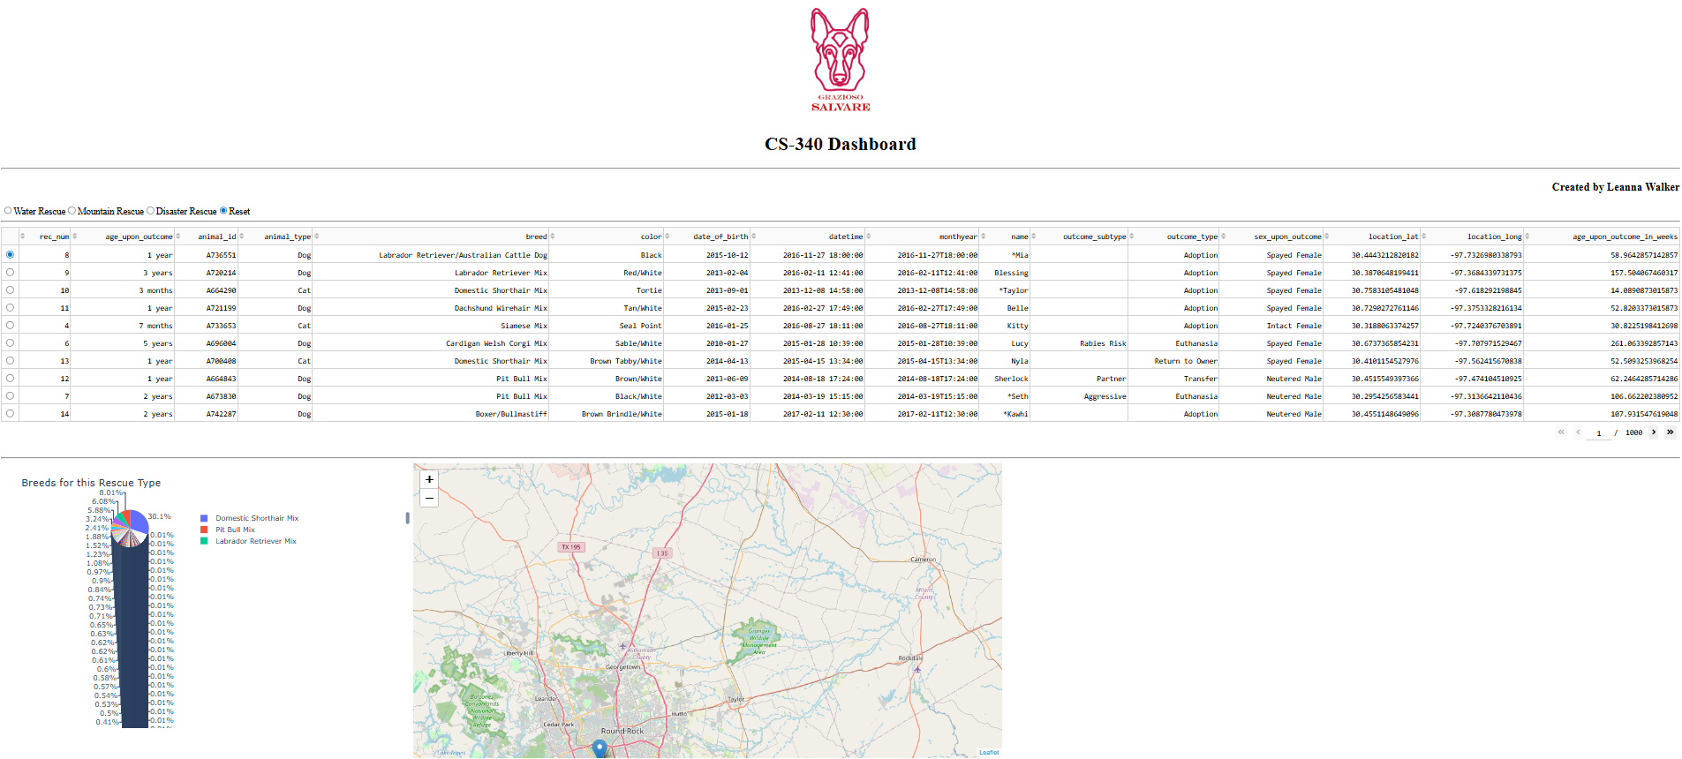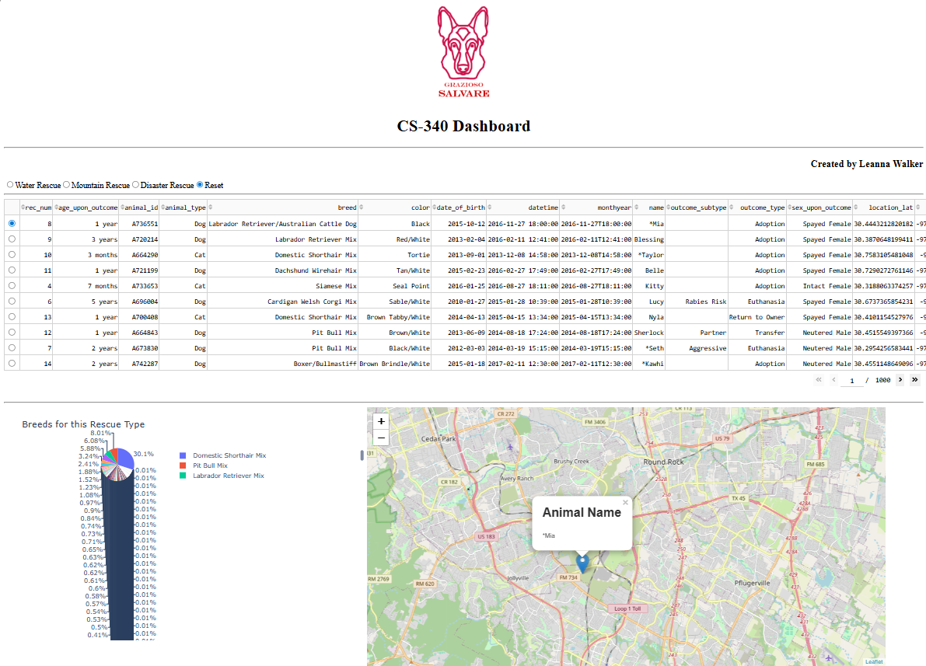
Water Rescue:
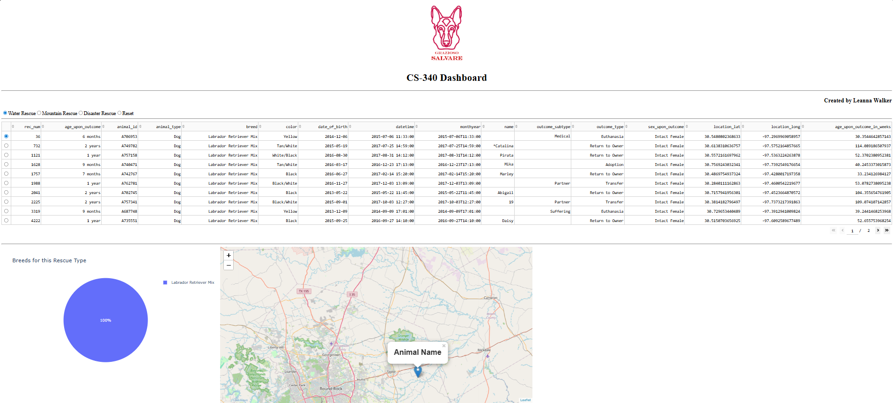
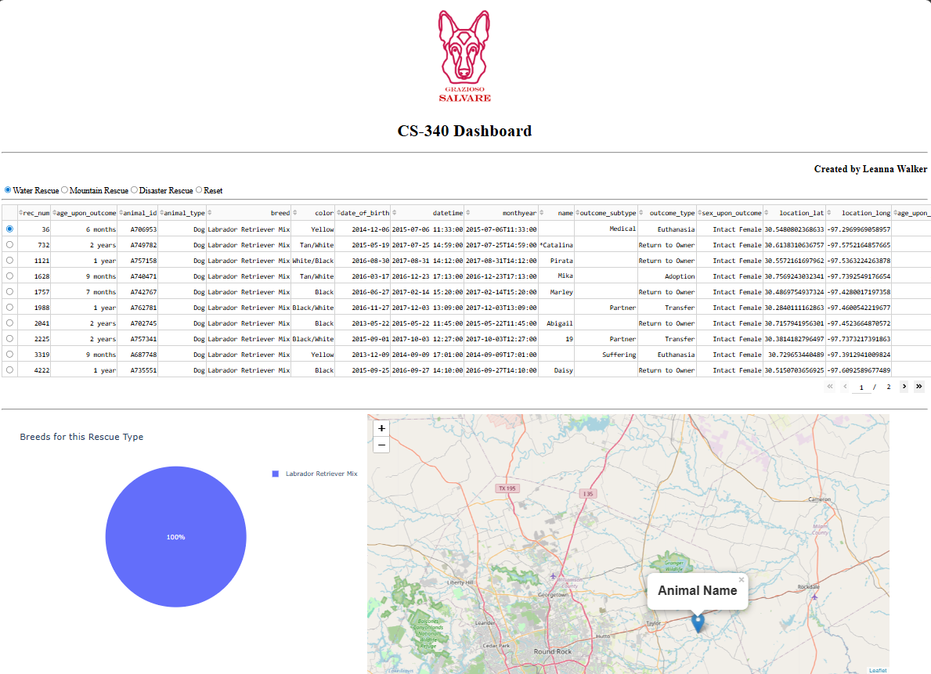
Mountain Rescue:
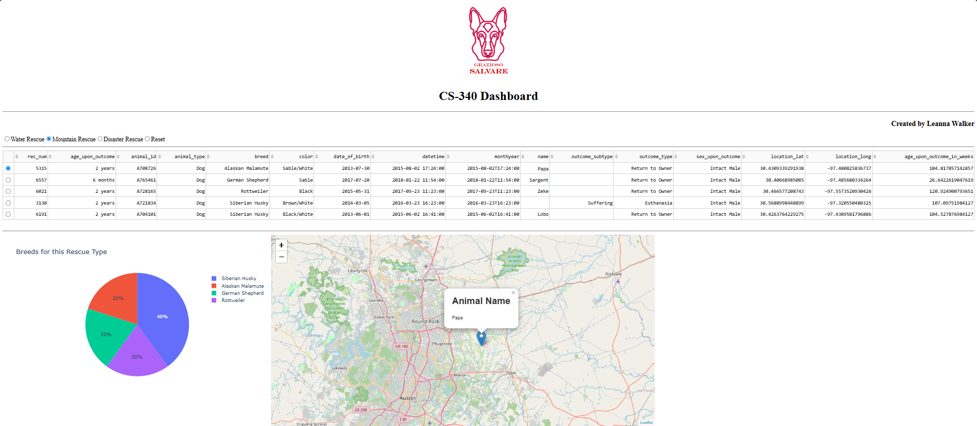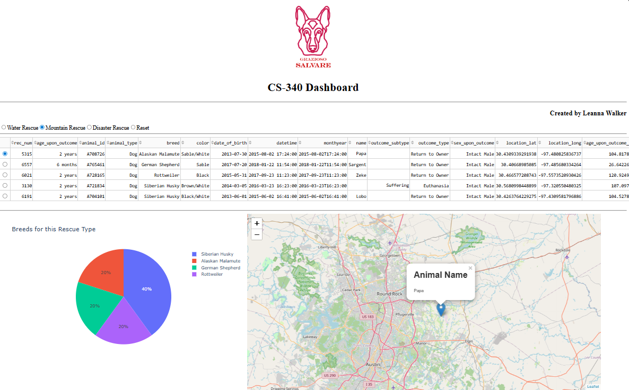
Disaster Rescue:
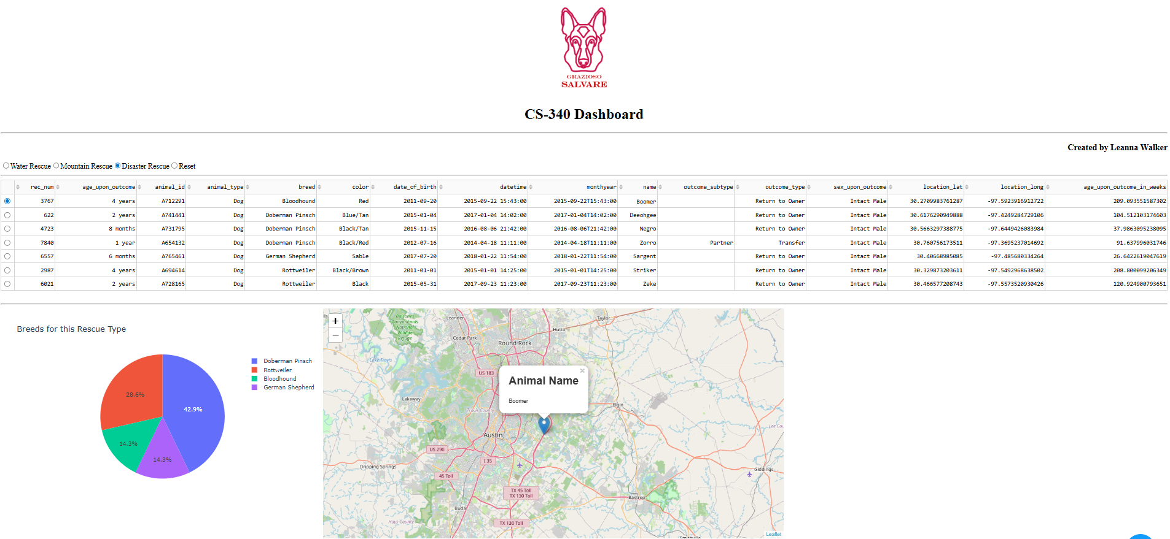
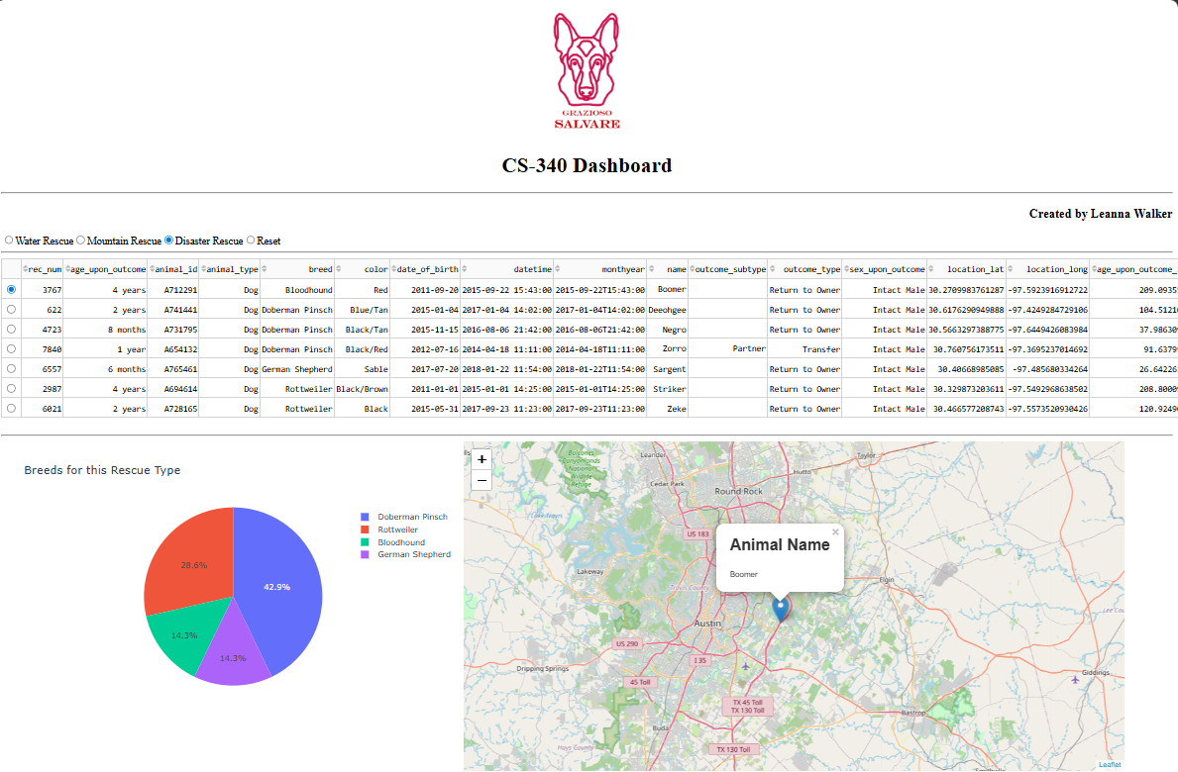

Development Steps
To begin creating the dashboard, I used the starter code and added the radio buttons. Then I wrote the callback to filter the data table. After that, I added the pie chart using Plotly and the map using Dash Leaflet. I also added the Grazioso Salvare logo and adjusted its size and placement on the dashboard. Finally, I fixed errors I had such as the breed name mismatches and indentation issues.

Challenges
When creating this dashboard, I encountered several issues I had to work through to get it up and running properly. First, the dashboard would crash or show error messages because some callbacks were trying to use data that didn’t exist yet, such as the map trying to show a location before a row was selected. To fix this, I added if statements that check if the data exists before trying to use it. Another problem was the initial sizing of the logo when I added it into the dashboard, it was huge and all the way to the left. To fix this, I added style={‘height’: ‘200px’, ‘width’: ‘auto’} to make it smaller and then used html.Center() to center it. I also had an issue where the breed names from the specifications document did not match how they were listed in the dataset. Such as “Chesapeake Bay Retriever” was labeled as “Chesa Bay Retr” in the data. So, no dogs showed up for some filters. I looked at the actual data, found the correct names, and updated the filter code to match.

Contact
Leanna Walker

